A county-wide coalition to promote racial and social justice through
inclusion, diversity, equity, and access.
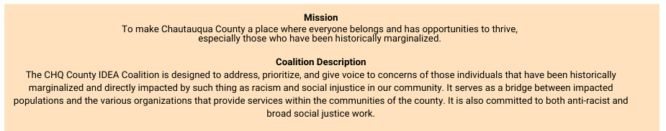

Community Members to be on Solutions Team (12 open positions)
Job Description

LOCATION : Chautauqua County
REPORTS TO: IDEA Coalition Project Director
EMPLOYER: United Way of Southern Chautauqua County
COMPENSATION: Stipend: $40 per meeting
TIME COMMITTMENT
1-2 meetings per month (estimated 1.5 – 2hrs per meeting)

Community members on the Solutions Team are part of the IDEA Coalition to achieve its mission and strategic outcomes. Other team members include IDEA Coalition organizations and “content” experts.

Community members on the solutions team have demonstrated and direct experiences in one of the following areas as a member of the African-American/Black and/or Latino/Hispanic community living in Chautauqua County:
- Business/Entrepreneurship, Employment/Jobs
- Community/Social Activities
- Education System

CORE RESPONSIBILITIES
- Consistently attend and participate in solutions team meetings to discuss the specific issues of their assigned solutions group, providing their input.
- Bring their knowledge of the issue as it relates to the specific solutions group and amplify the voices of the community.
- Leverage their community connections to discuss solutions offered by their assigned solutions team.
- Community member must have direct experience or direct impact with their assigned solutions group category.

CHARACTERISTICS:
- Person who is willing and able to share their story authentically expressing their impacts from these issues.
- Passionate about finding solutions for these issues in their community.
- Respected and trusted within their community.

Contact Person:
- If you or anyone you know that are interested in being a Community Member for any of the IDEA Coalition Solution Team, please email the Project Director, Bishop Leecroft Clarke at IDEA Director IDEA-Director@uwayscc.org.

