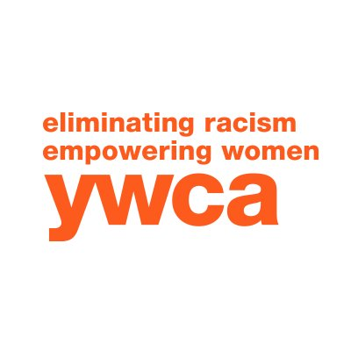
Jamestown

Program | Summary | Length | Fee
Developing our Cultural Responsiveness | Designed to give participants an introduction to cultural competency by exploring the participant’s cultural awareness and steps to increase cultural competency.  Topics include:  Cultural responsiveness/competency  Understanding our biases  Microaggressions  Diversity, Equity, & Inclusion (DEI)  Linguistic competency  LGBTQ+ competency introduction  *These topics may also be their own individual workshop | Varied  4 hours | $35 per participant  $25 per participant for review training (Example: follow-up training on a specific topic discussed in previous training within a year)
What’s the big IDEa?  (...with Diversity, Equity, and Inclusion) | Explores diversity, equity, and inclusion and why learning and incorporating these concepts can help the participant (and organization) deliver comprehensive services. | Varied  3-8 hours | See above
Understanding Generational Poverty | The largest traditionally marginalized cultural group in Chautauqua County and surrounding area is low-income/poverty cultural group. Generational poverty will be defined and techniques to better provide services to this community will be examined. | Varied  3-8 hours | See above
Race, ethnicity, and social justice | This training’s goal is for the participant to begin to understand fundamental concepts such as racial equity and structural racism. It will explore the benefits of talking about race, ethnicity, privilege, and discrimination in organizations and how to counteract racial and ethnic inequities in the workplace. | Varied  2-4 hours | See above
Working with My Community | This training can be customized to deliberate, review, and examine all above concepts and strategize how an individual and organization can become more culturally responsive with the community they serve.

All training and workshops include activities and exercises to employ different learning methods and demands. Discussion is strongly encouraged and welcomed. Please contact Indo Quinones for more information: (716) 488-2237 or iquinones@ywcajamestown.com

